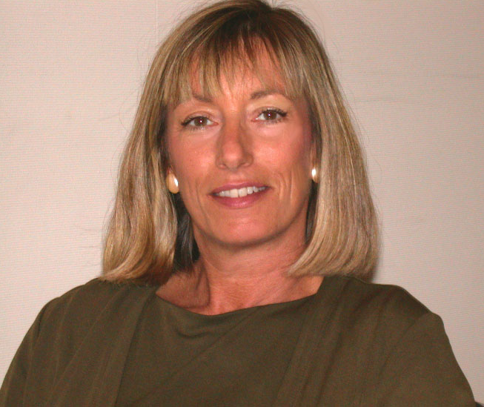
Suzan Fiskin

Productive Learning & Leisure

Suzan is an accomplished business consultant and Certified Business Coach with 10 years of experience in the profession. She is also a highly skilled and inspiring platform speaker. She works with business leaders, elite sales professionals, and entrepreneurs in high tech and service companies to significantly build capability and profitability.

A communications expert with special expertise in the area of presentations and communications skills, she works with executives, managers, entrepreneurs, and business development professionals to lead more effectively, communicate powerfully, and to deliver persuasive presentations.

A master of Neuro-Linguistic Programming (most notably used by Tony Robbins as the foundation of his work) with 19 years in the field, she built and ran a successful marketing business in Marin County, California for 10 years working with clients like AutoDesk, Birkenstock and a many high tech entrepreneurial organizations.

She served on the Board of Directors of the Professional Coaches and Mentors Association for 3 years, volunteers her time coaching presenters for Southern California Venture Network, and is the Chair of the Association of Women in Technology Mentoring Program. She is also on the board of the Orange County chapter of the Forum For Women Entrepreneurs.

She’s worked with clients in the US Army; Booz, Allen, Hamilton; Oracle; LA Unified School District; Oppenheimer; and many, many others.

Suzan is currently a highly entertaining and informative presenter for Productive Learning & Leisure.

Insight, humor and innovative solutions to seemingly complex problems are hallmarks of her work.

800-300-3036

http://www.productivelearning.com

