

Official Supplier to the 2000-20

Introduces the.….
Bio Photonic Scanner

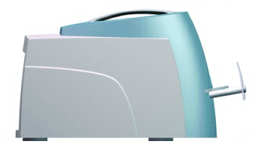
Do you know what your Antioxidant Levels are?

This test takes less than 3 minutes, it is non-invasive, painless and gives you your Body Defense Score.


ORANGE COUNTY OCCN
May Food Sponsors will be PHARMANEX

Introducing their new:

BIO-PHOTONIC/ANTIOXIDANT LASER SCANNER

Speaker: Karen Johnson, Director PHARMANEX

Tuesday, MAY 20th, 2003

FREE SCANNING FROM 7:00 pm TO 9:00 pm

Karen Johnson 310-245-2020, (www.WhatsYourBDS.com)

Official Nutritional Supplier to the 2000-2002-2004 U.S. Olympic Team

